**PMWebSpec Application Setup User Guide**

# **Application Introduction –**

PMWebSpec is a Web Based Application developed using CodeIgniter based PHP Programming language (Version 5.5 – 7.4). Frontend is developed in HTML5, CSS, JavaScript, Bootstrap and MySQL as database.

# **Application Architecture –**

**Backend** - PHP CodeIgniter (MVC Structure)

**Database** – MySQL

**Frontend Tech** – HTML5, JavaScript, CSS, Bootstrap

# **Software Required –**

## **Local Setup –**

*Note: - The installation process is specific to Windows OS and steps may differ for other operating systems.*

* Xampp Server (PHP 7.4 - Recommended)
* Any Editor (Sublime - Preferred) **- Optional**

### Xampp Server Setup: Installing this Xampp server will install both PHP and MySQL database.

* 1. Download Xampp server from <https://www.apachefriends.org/download.html>

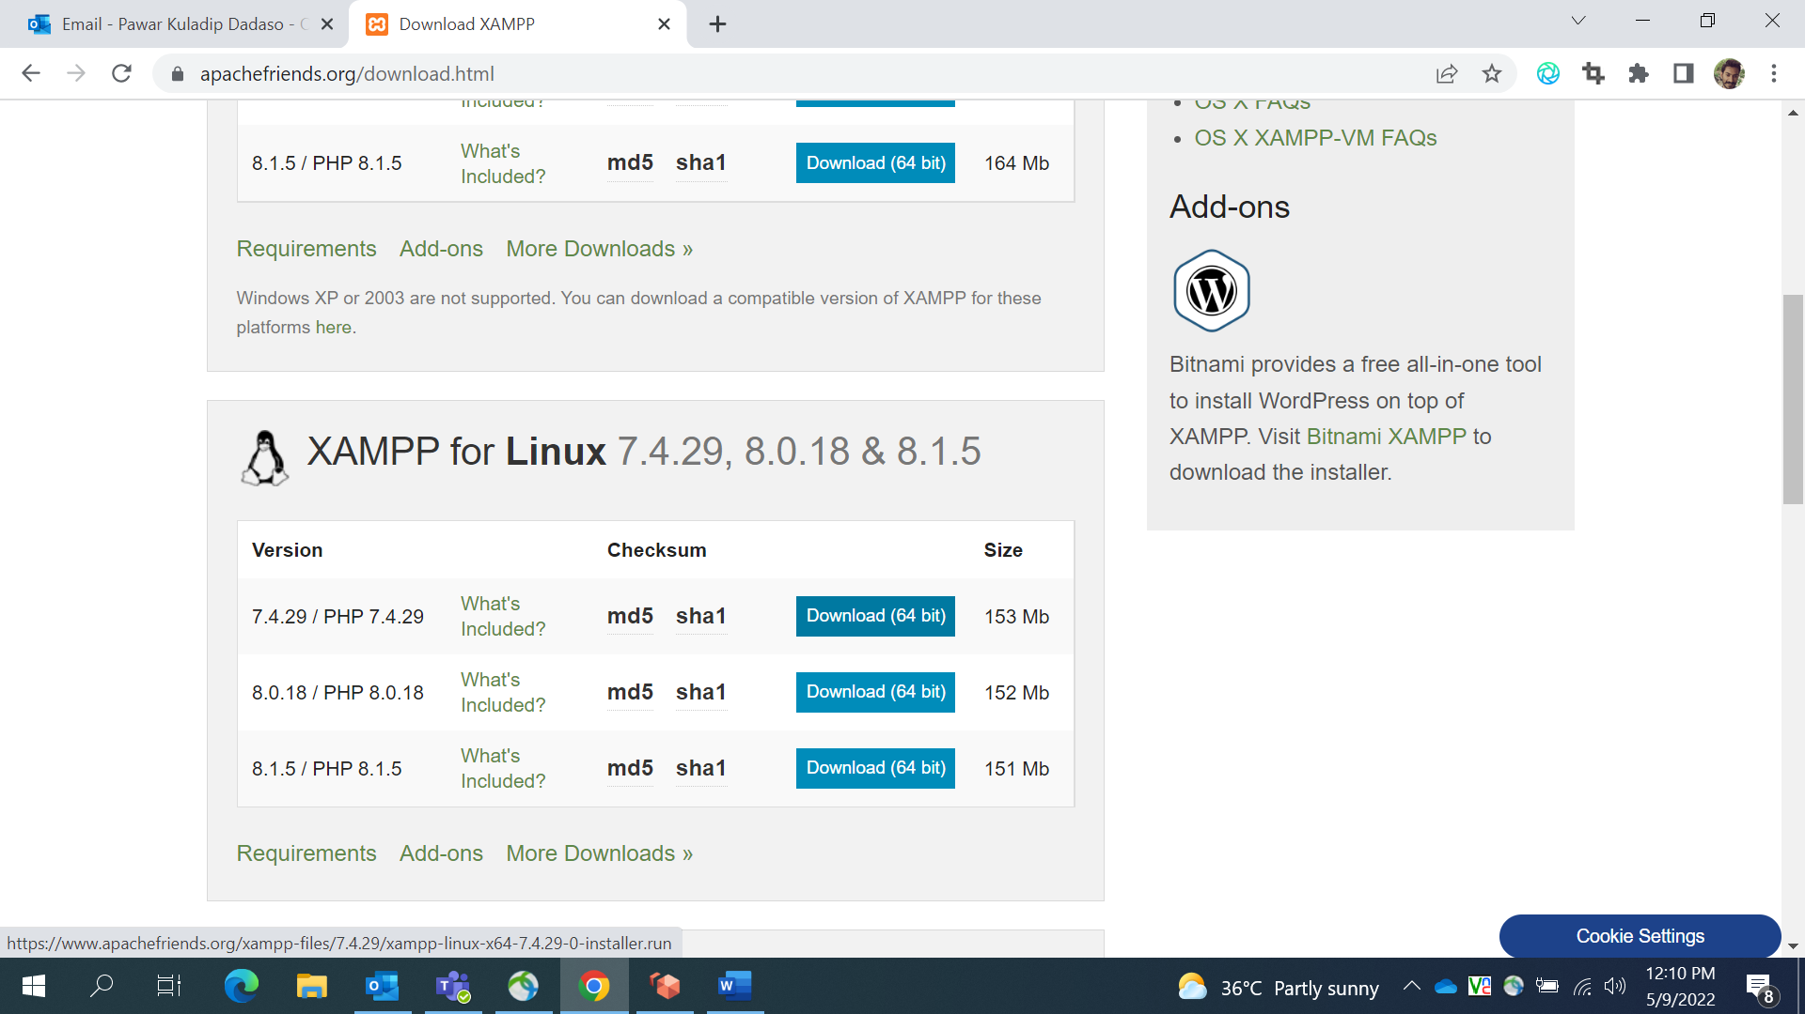

* 1. Download and install exe file according to the operating system
* Preferred installation location is C:\ drive
* After successful installation of Xampp, System will generate auto created folder named ‘xampp’ in **C:\** location
  1. Start Apache and MySQL server from toolbar

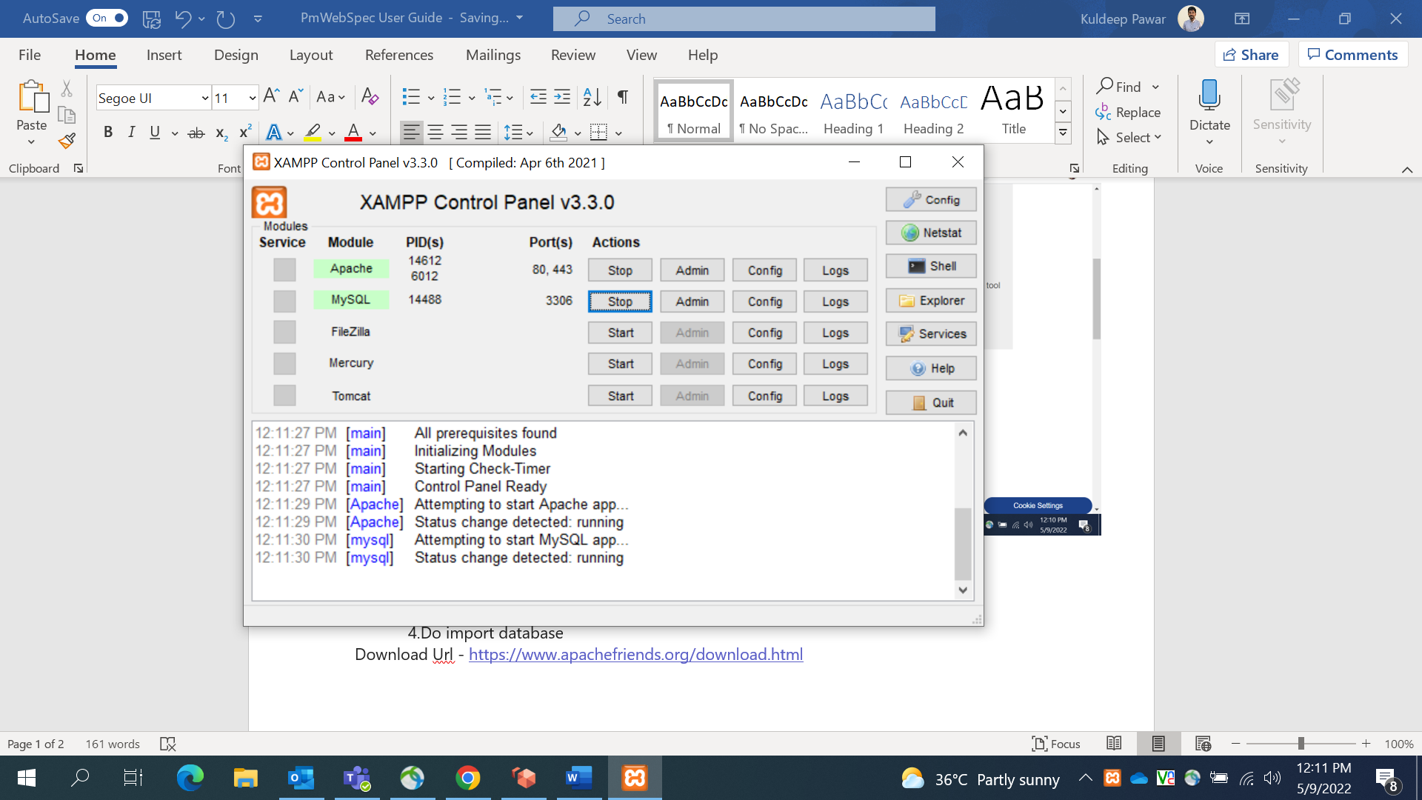

* 1. After Xampp setup and application server is started, import databases.

### **Database Configuration:**

**Databases** – PMWebSpec contains two databases

* dbstruct_ci_test
* web_based_spec_ci_test

**Steps for importing Database –**

1. Go to PhpMyAdmin page (<http://localhost/phpmyadmin>)

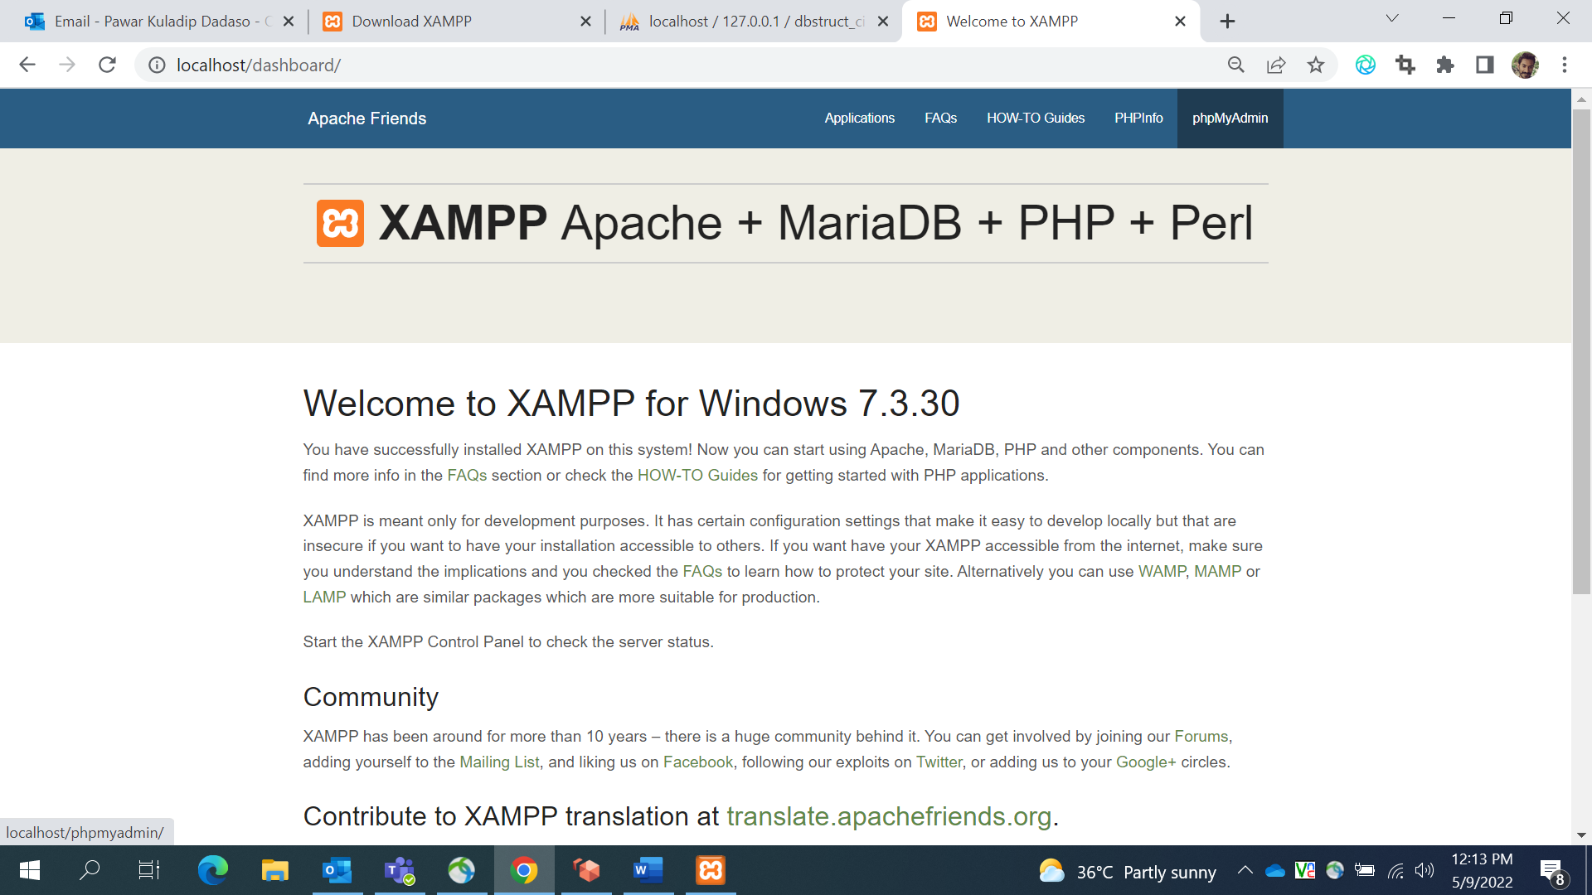

1. Create Database – dbstruct_ci_test and web_based_spec_ci_test

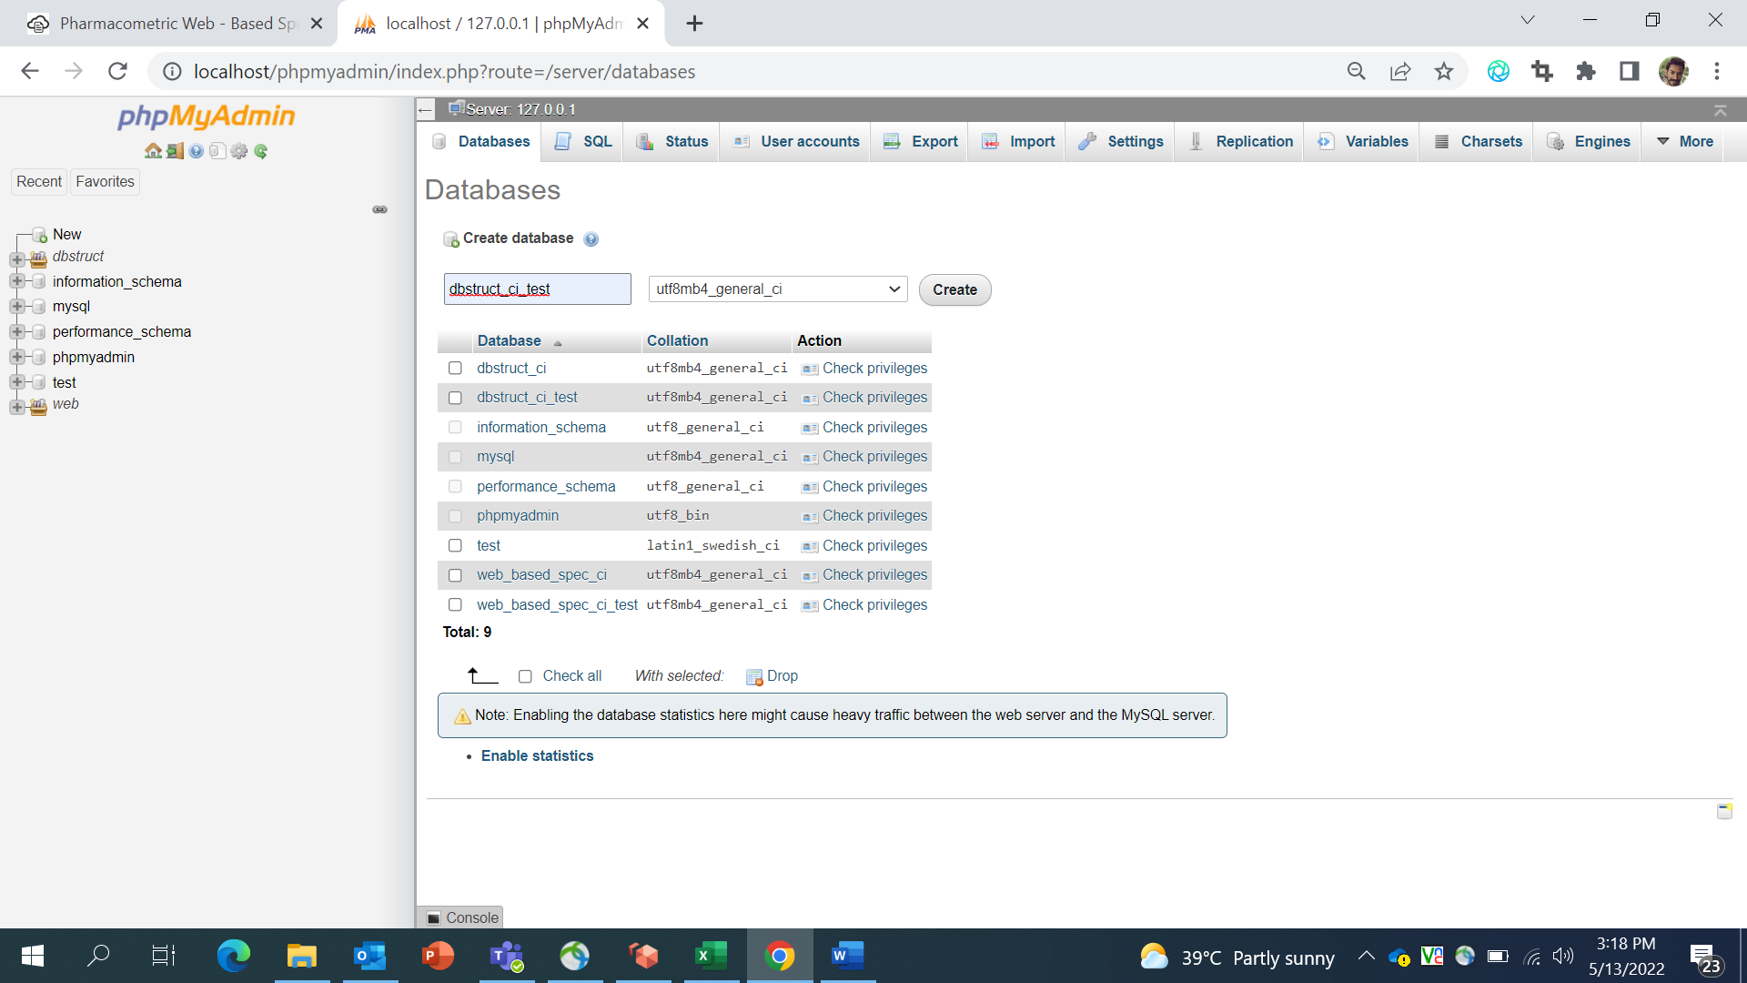

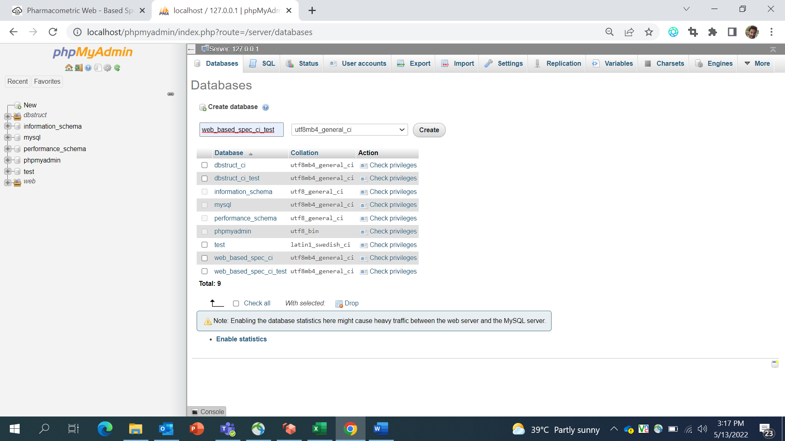

1. Go to Import tag and choose sql file as per database name (The sql file will be available on SVN)

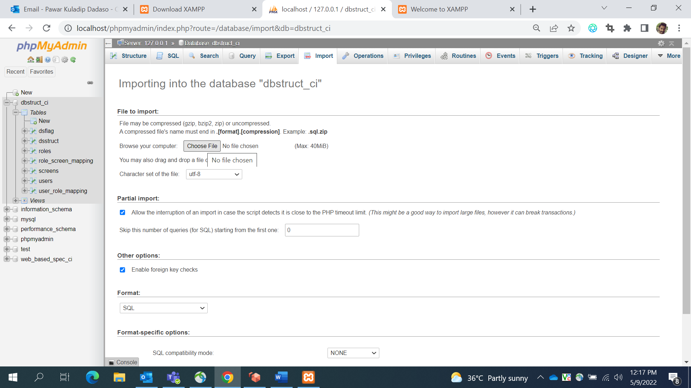

1. Click on Go button at the bottom of the screen to submit
2. Configure databases into localhost and accordingly set database credentials in database.php file. the file available in **C:\xampp\htdocs\PmWebSpec_dev\pframe\config\** folder.

## Code Setup –

* 1. Create **“PmWebSpec_dev”** folder in **C:\xampp\htdocs\** location
  2. Copy the file **GIT_Demo_Sandbox_11May22.zip** from GitHub (location) and Extract into above folder.

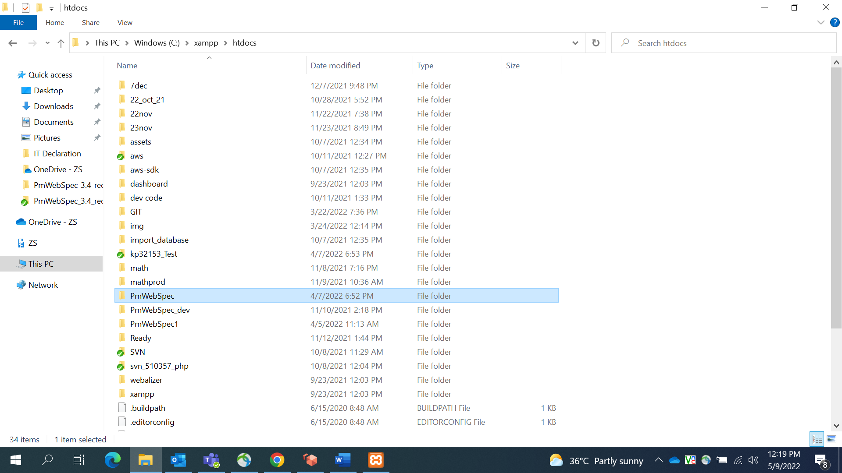

* 1. Configure databases into localhost and accordingly set database credentials in database.php file. the file contains in PmWebSpec_dev \pframe\config\ folder.
  2. Run the application on local using the URL - <http://localhost/PmWebSpec_dev/home>
  3. To grant all access rights for pmwebspecadmin in local system, the command needs to be executed in dbstruct_ci_test database

GRANT ALL ON *.* TO 'pmwebspecadmin'@'%' IDENTIFIED BY 'complex-password';

